**MATHEMATICS APPLICATIONS**

**Test 4 2018**

**Matrices**

**Section A-Resource Free**

**Marks: 32 Time Allowed: 30 minutes**

**Name: _______________**

**ALL** working must be shown for full marks.

**For any answers that do not exist an explanation must be given.**

**Question 1** **[11 marks]**

Use the following matrices to answer the questions below.

For any answers that do not exist give an explanation why.

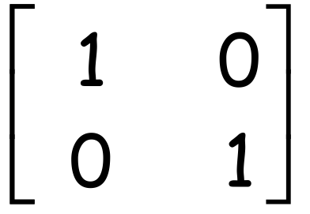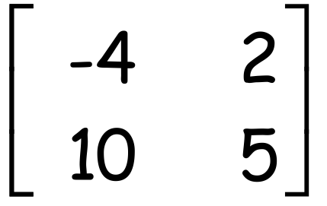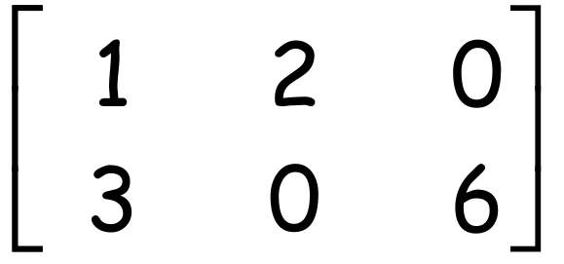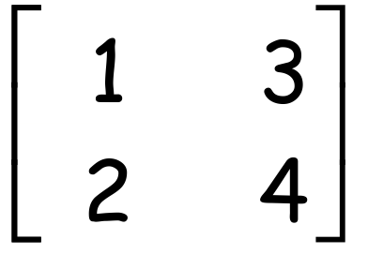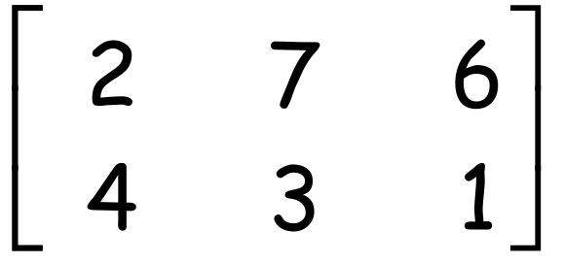

**A** = **B** = **C** = **D** = **E** =

1. Give the value of c23.
2. Give the value of c32.
3. Calculate **A** + **B**
4. Calculate **B** - **D**
5. Calculate 2**A**
6. Calculate 2**A** + **C**
7. Give the dimensions of **C**
8. What is the name given to the Matrix **E**

**Question 2 [1, 1, 1, 1, 2 = 6 marks]**

Give an answer of True or False for the following.

1. A matrix of order 3x4 will have 34 elements.
2. For the 2x2 matrices **A** and **B**

**A** + **B** = **B** + **A**

1. For the 2x2 matrices **A**, **B** and **C**

(**A** + **B**)+ **C** = **A** +( **B** + **C**)

1. For the 2x2 matrices **A** and **B**

**A**x**B** = **B**x**A**

1. For the 4x3 matrix **A** and the 3x5 matrix **B**

**i)** the dimensions of **A**x**B** are 4x5

**ii)** the dimensions of **B**x**A** are 3x3

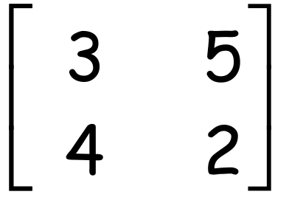**Question 3** **[ 5 marks]**

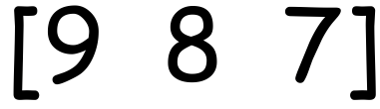If matrix **A** is given by **A** = and matrix **B** is given by **B** =

1. Calculate **A**2
2. Calculate **B**2

**Question 4** **[2, 2, 2, 1 = 7 marks]**

Calculate the following products. If any are not possible give an explanation why.

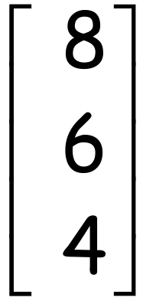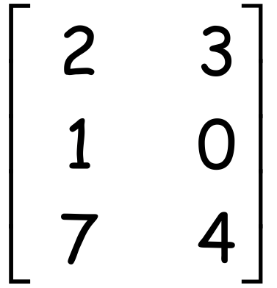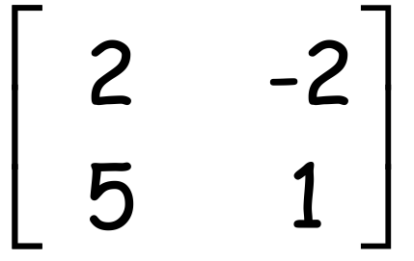

1. 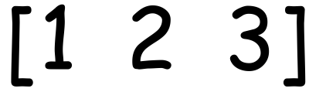 X **b)** X

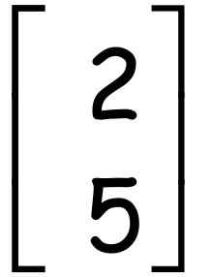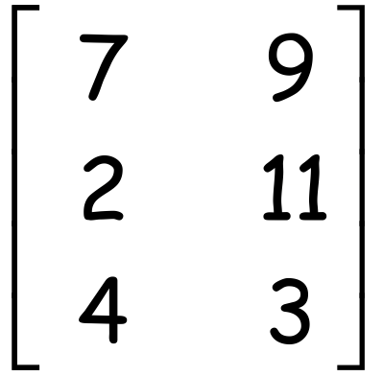

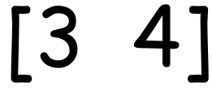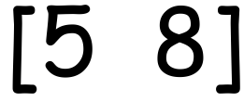 **c)** X **d)** X

**Question 5**  **[3 marks]**

For the 2x2 matrices **A**, **B**, **C** and **D**

1. **A** + **B** = **A** if matrix **B** is a Matrix
2. **A** x **C** = **A** if matrix **C** is a Matrix

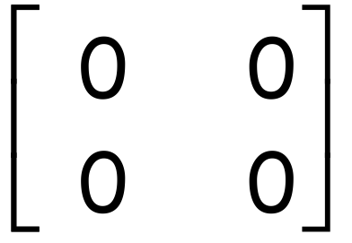

1. **A** x **D** =if matrix **D** is a Matrix

**MATHEMATICS APPLICATIONS**

**Test 5 2018**

**Matrices**

**Section B-Resource Assumed**

**Marks: 29 Time Allowed: 30 minutes**

**ALL** working must be shown for full marks.

**For any answers that do not exist an explanation must be given.**

**Question 1** **[2, 1, 1, 1, 1, 3 = 9 marks]**

1. Construct a route matrix **R** for the following network showing Ben’s trip to school.

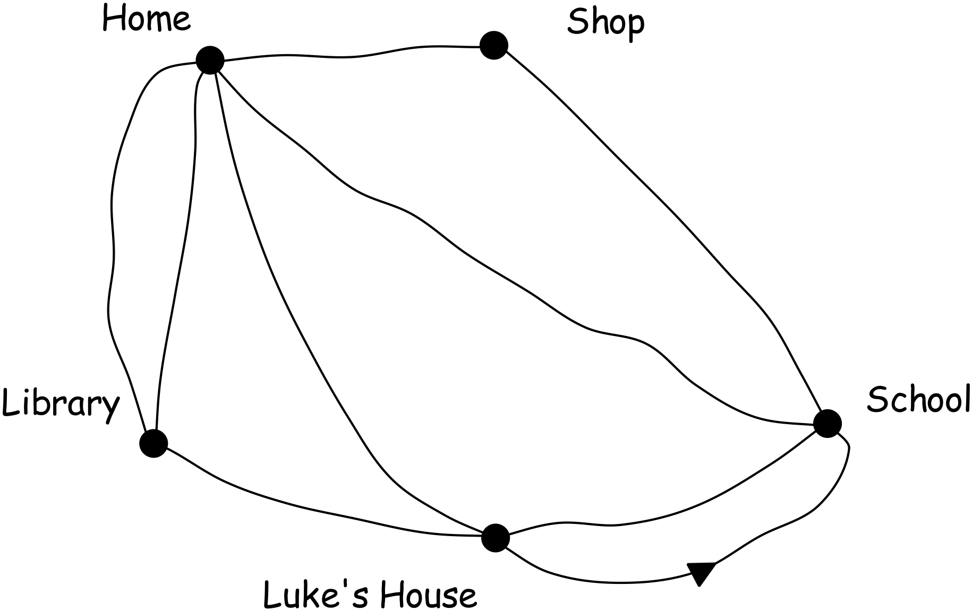To

**H Sh Sc Li Lu**

**R = H**

**Sh**

From  **Sc**

**Li**

**Lu**

1. The two stage route matrix can be obtained by doing what to the original route matrix?
2. Give the two stage route matrix for Ben’s trip to school.
3. How many ways can Ben get to school if he makes one stop on the way?
4. How many ways can Ben get home from school if he makes one stop on the way?
5. On the way home from school today Ben needs to make two stops.

**i)** What needs to be done to matrix **R** to show these paths?

**ii)** Show this matrix

**iii)** How many ways can Ben get home if he stops at Luke’s house and the library?

**Question 2 [ 3, 4, 3 = 10 marks]**

1. Find the value of x and y if

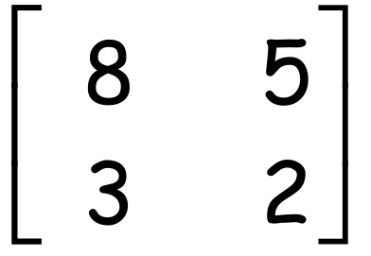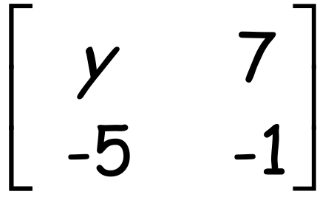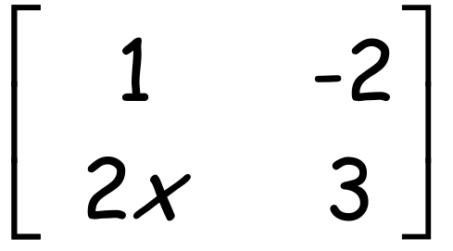

+ =

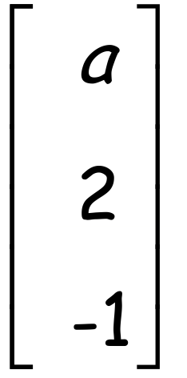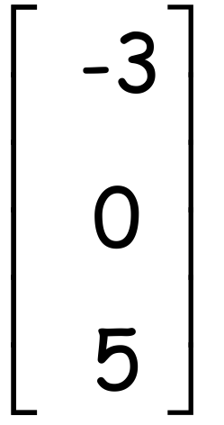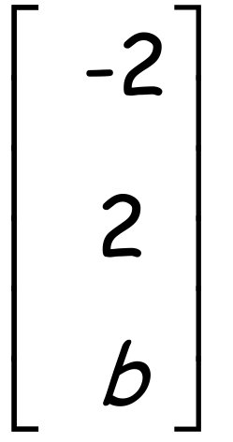

1. Find the values of a and bif **P** = **Q** = **R** = and **P + 2Q = R**

1. Find the values of m and nif

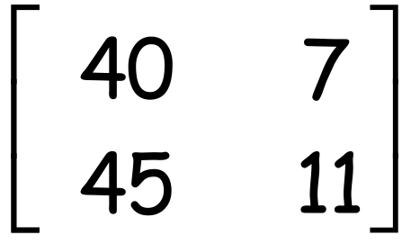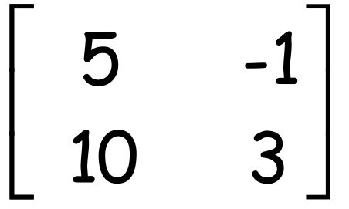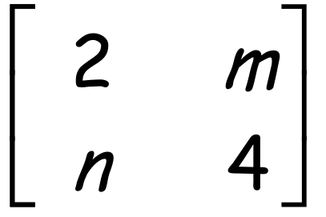

X =

**Question 3** **[2, 2 = 4 marks]**

1. If amn is the element situated in the mth row and nth column of a 2x4 matrix **A**.

Write down matrix **A** if amn = 4m-n.

1. Matrix **B** has a square number of elements less than 65, but is not a square matrix. It is a rectangular matrix with 12 less columns than rows. What is the order of matrix **B**

**Question 4 [1, 1, 3, 1 = 6 marks]**

The table below shows the seat prices for three different seating areas of His Majesty’s Theatre Perth.

|  |  |  |  |
| --- | --- | --- | --- |
| Ticket Cost | Grand Circle | Dress Circle | Stalls |
| **Adult** | $170 | $150 | $120 |
| **Concession** | $155 | $130 | $90 |

1. Represent this information as the 2x3

matrix **C.**

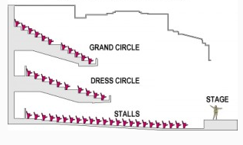

The number of tickets sold for the Saturday night performance is given in the table below.

|  |  |  |
| --- | --- | --- |
| Tickets sold | **Adult** | **Concession** |
| Grand Circle | 158 | 122 |
| Dress Circle | 287 | 153 |
| Stalls | 97 | 103 |

1. Represent this information as the 3x2 matrix **T.**
2. Give the matrix that will show the total money made on ticket sales for each section of the theatre.
3. What is the money made on total ticket sales for the Saturday night?